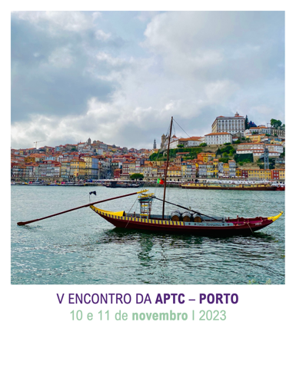
V Encontro da APTC - Porto
Registration Form
Identification
Name
Affiliation
Address
VAT number (if needed)
E-mail
Telephone

Registration:
Student* | [ ]
Member of APTC** | [ ]
Other professionals | [ ]

* Refers only to full-time students. Registration form must be accompanied by a proof of status.
** Members of APTC with paid membership fees. This category includes members of all associations of the EABCT.

 | Registration (please indicate one option)
 | Other students |  | Members of APTC |  | Other professionals
1 day of training (WS of 1 Day or 2 WS of Half-Day) | 90€ | [ ] | 110€ | [ ] | 130€ | [ ]
2 days of training | 110€ | [ ] | 130€ | [ ] | 180€ | [ ]

 | Please select the DAY and WORKSHOP(S) you wish to register
November 10 | W1 [ ] W2 [ ] W3 [ ] W4[ ]
November 11 | W5 [ ] W6 [ ]
W1. El trastorno obsesivo-compulsivo en niños y adolescentes: El papel del perfeccionismo I Aurora Gavino, University of Malaga, Spain
W2. Understanding and treating Death Anxiety I David Veale, King’s College, London, UK
W3. Ethical dilemmas in clinical practice and supervision: Are there easy answers? I Agnieszka Popiel, University of Social Sciences and Humanities, Warsaw, Poland
W4. Treating Body Dysmorphic Disorder I David Veale, King’s College, London, UK
W5. Creating new ways of being for ourselves: A self-practice/self-reflection (SP/SR) workshop I Tobyn Bell, University of Manchester, UK
W6. Internet e videojogos: Amigos ou inimigos? Conceptualização, avaliação e intervenção na adição à internet I João Faria, Partners in Neuroscience I PIN, Portugal
Note. The workshop will be lectured in the language of its title.
PAYMENT • Payment of registration fees must be made in EUR through bank transfer.
Account Name: ASSOCIACAO PORTUGUESA TERAPIA COMPORTAMENTO
Bank Details: CAIXA GERAL DE DEPOSITOS
Swift No: CGDIPTPL
Account Number: 0809002710930
IBAN Number: PT50 0035 0809 00002710930 97

Please send the registration form and proof of payment to ljdsecretariado@gmail.com

The e-mail subject should be “Registration – V Encontro da APTC - Porto”.

